Common Core Algebra 1
Unit 9 Content Assessment: STATISTICS

Name: __________________________________________ Class: ________ Date: ______________________________
- Evan asked people if they play hockey and also asked if they play soccer.

 | Play Hockey | Do not play Hockey | Total
Play Soccer |  |  | 31
Do not play Soccer | 3 | 6
Total |  | 25

What percent of the people play soccer but do not play hockey?

- 19 C) 48

- 76 D) 61

- The 8th grade class at Albert Gallatin South Middle School held a competition to collect the most number of canned goods to donate to a local charity. In the competition, the class was split into two teams, each donating as many goods as possible. At the end of the competition, the team with the greater average number of canned goods per student won. The eight students on Team 1 collected 195, 87, 62, 271, 103, 149, 51, and 70 canned goods. The nine students on Team 2 collected 46, 429, 101, 72, 33, 100, 64, 58, and 125 canned goods. Which team won the competition?

A) Team 1
B) Team 2
C) The teams were tied
D) There is not enough information.

- Consider the following types of data: letters per word & sleep times.
_________ a) Are letters per word qualitative or quantitative?
_________ b) Are sleep times qualitative or quantitative?
_________ c) Which data set is continuous?
_________ d) Which data set is discrete?

- The charts below shows the age of the actress & actor who won the Oscar for best actress or actor during the first 30 years of the Academy Awards.
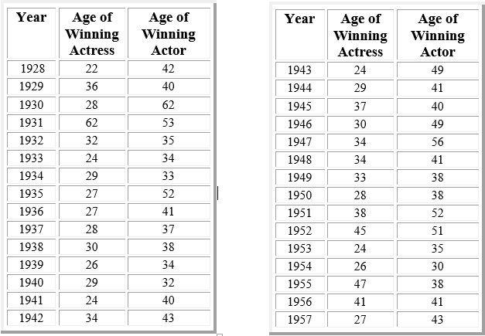

If you wanted to compare the ages of the male Oscar winners to the ages of the female Oscar winners,
What type of data display would you use to support your comparison? Explain your reasoning.

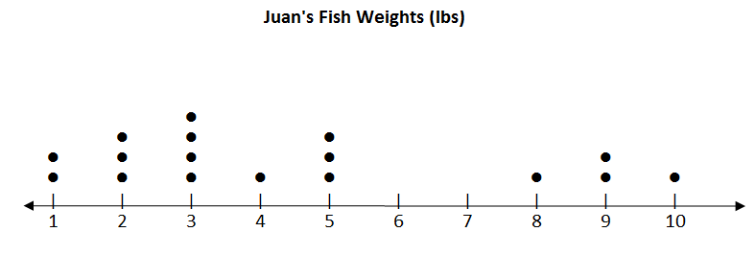
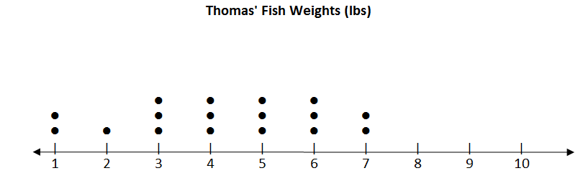
- Two fishermen, Juan and Thomas, compiled dot plots for the weights of the fish they caught one day. The dot plots are shown below.
Which is true about the two sets of weights?
A) The range of weights of Thomas’ fish is greater than the range of weights of Juan’s.
B) The median weight of Juan’s fish is greater than the mean weight of Thomas’.
C) The maximum weight of Thomas’ fish is greater than the maximum weight of Juan’s
D) The mean weight of Juan’s fish is greater than the median weight of Thomas’.
- Two histograms are shown below.

Which is most likely true about the data?

- The ranges of the data sets are the same.
- The standard deviations of the data sets are the same.
- The mean in Histogram 2 is less than the mean in Histogram 1.
- The outliers in Histogram 1 affect the median more than the mean.

- An app store kept track of sales over the course of one day. They categorized the sales based on whether the download was a free or premium app, and recorded the type of download. They calculated conditional frequencies of the sales and made the table below.
 | Games | Music | Educational | Total
Free App | 0.08 | 0.20 | 0.10 | 0.38
Premium App | 0.28 | 0.02 | 0.32 | 0.62
Total | 0.36 | 0.22 | 0.42 | 1.00

Which prediction is true regarding the distribution of free and premium apps? CHOOSE ALL THAT APPLY!
- If there were a total of 75 sales in one day, 27 would be game apps.
- If there were a total of 75 sales in one day, 8 would be educational apps.
- If there were a total of 75 sales in one day, 24 would be premium educational apps.
- If there were a total of 75 sales in one day, 27 would be free apps.

- Fred ran 12 laps around the running track at his school. His times (in seconds) for each of the 12 laps are shown below.

108 108 105 110 115 116 118 118 118 95 102 97

Step A

Find the “5-Number Summary” for the set of data and record each number in the chart below.

Minimum | Lower Quartile | Median | Upper Quartile | Maximum

Step B
- Use the number line below to make a box-and-whisker plot to show this data.

⏐ ⏐ ⏐ ⏐ ⏐ ⏐ ⏐ ⏐ ⏐ ⏐ ⏐ ⏐ ⏐ ⏐ ⏐ ⏐
90 100 110 120

- What percent of Fred’s laps were slower than 117 seconds? Use what you know about box-and-whisker plots to justify your answer. Use words, numbers, and/or symbols in your explanation.

For questions 9-12 Identify the letter of the choice that best completes the statement or answers the question.
Math Test Scores
•
•
⏐ ⏐ ⏐ ⏐ ⏐ ⏐ ⏐ ⏐ ⏐ ⏐ ⏐ ⏐ ⏐ ⏐ ⏐ ⏐
25 30 35 40 45 50 55 60 65 70 75 80 85 90 95 100

- What is the median score of the math test?

  - 75 b) 70 c) 90 d) 80

- What percent of the students taking the math test scored at least 85?

  - 75% b) 25% c) 50% d) 100%
- What percent of the students taking the math test scored between 63 and 85?

- What is the range of the set of data?

